SESSION 15:

TASK 1:
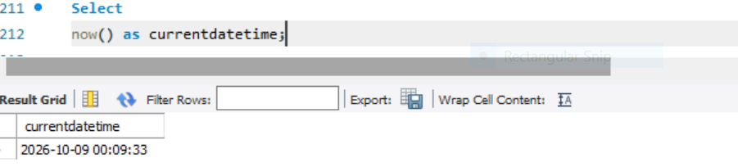

TASK 2:
use mydb;
select * from Orders;
select
Order_date,
year(order_date) as Order_year,
month(order_date) as Order_month,
day(order_date)
as Order_day from Orders;

TASK 3:
SELECT Delivery_date,
Date_sub(delivery_date, interval 2 day) as Expected_pickup_date from deliveries;

TASK 4:
Select
User_id, Start_date, end, Dated IFF(Start_date, end_date) as
total _days from subscriptions;

TASK 5:
Select
User_id, last_login_date from Applogins
Where Datediff(Now(), last_login_date ) >30;

